“EnviraLog: A Real-Time Campus Environmental Monitoring and Predictive Analytics Platform Utilizing IoT Sensor Networks, MQTT, Node.js, and React”
Rajeev Patel
Manis Khatri
The EnviraLog system is a real time, campus-wide environmental measurement and predictions system that utilizes IoT sensor networks, cloud-based data streaming, and machine learning to fill gaps in current ways of managing campus environments. By using Raspberry Pi Pico W microcontrollers with environmental sensors, the system measures temperature, humidity, air quality, and noise data from multiple locations on the campus. This data is sent to the Node.js backend via MQTT for storage in an InfluxDB and analyzed using machine learning algorithms for trend forecasting and identifying anomalies. Users can visualize real-time and historical data through a React dashboard which provides users access to all of the real-time information gathered by the EnviraLog system. The primary target users for the EnviraLog system are Facilities Management Staff, Researchers, and Administrators; the use of EnviraLog allows users to make better decisions regarding the environment and promotes sustainability efforts while also being an educational tool for IoT and Data Science applications. The project demonstrates a scalable, full-stack solution for intelligent campus monitoring.
rpatel5@university.edu | mkhatri@university.edu
469-739-7673 | 337-419-8124

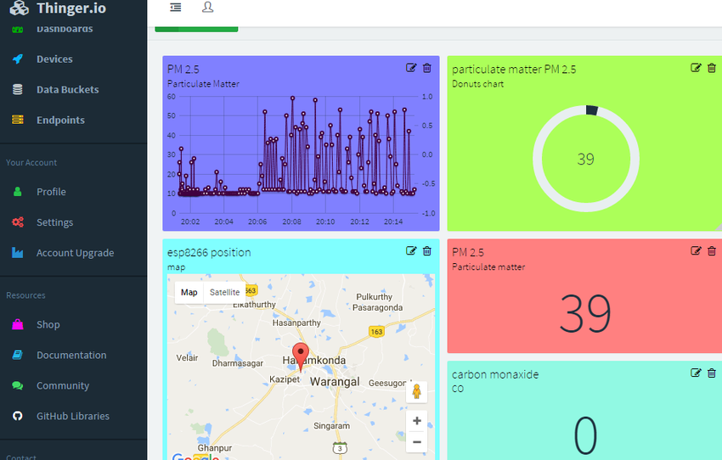
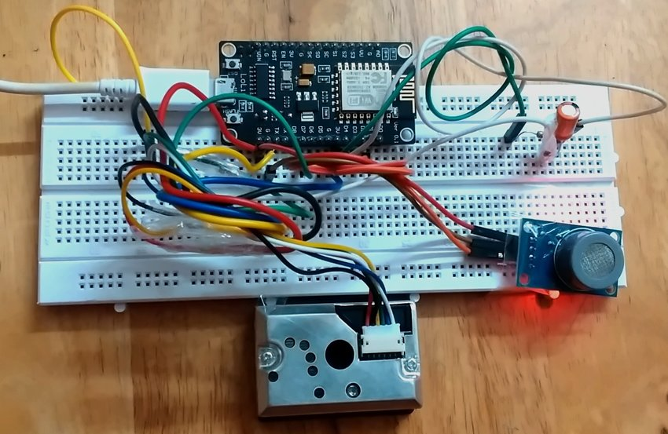
Kodali, R. K., & Sarjerao, B. S. (2017, December). MQTT based air quality monitoring [Conference paper]. ResearchGate. https://www.researchgate.net/publication/323217114

